**DAILY ONLINE ACTIVITIES SUMMARY**

|  |  |  |  |  |  |  |  |  |
| --- | --- | --- | --- | --- | --- | --- | --- | --- |
| **Date:** | **30/05/2020** | | | | | **Name:** | **Nivedita** | |
| **Sem & Sec** | **4th sem/ A-sec** | | | | | **USN:** | **4al18cs053** | |
| **Online Test Summary** | | | | | | | | |
| **Subject** | | **DC**  **maths** | | | | | | |
| **Max. Marks** | | **30**  **30** | | **Score** | | | **27**  **27** | |
| **Certification Course Summary** | | | | | | | | |
| **Course** | **Introduction of iot** | | | | | | | |
| **Certificate Provider** | | | **Cisco networking** | | **Duration** | | | **20 hours** |
| **Coding Challenges** | | | | | | | | |
| **Problem Statement: Write a C Program to count Uppercase, Lowercase, special character and numeric values for a given String** | | | | | | | | |
| **Status:done** | | | | | | | | |
| **Uploaded the report in Github** | | | | | **yes** | | | |
| **If yes Repository name** | | | | |  | | | |
| **Uploaded the report in slack** | | | | | **yes** | | | |

Online Test Details: (today test was DC 0f 30 marks.module 3 and module 4.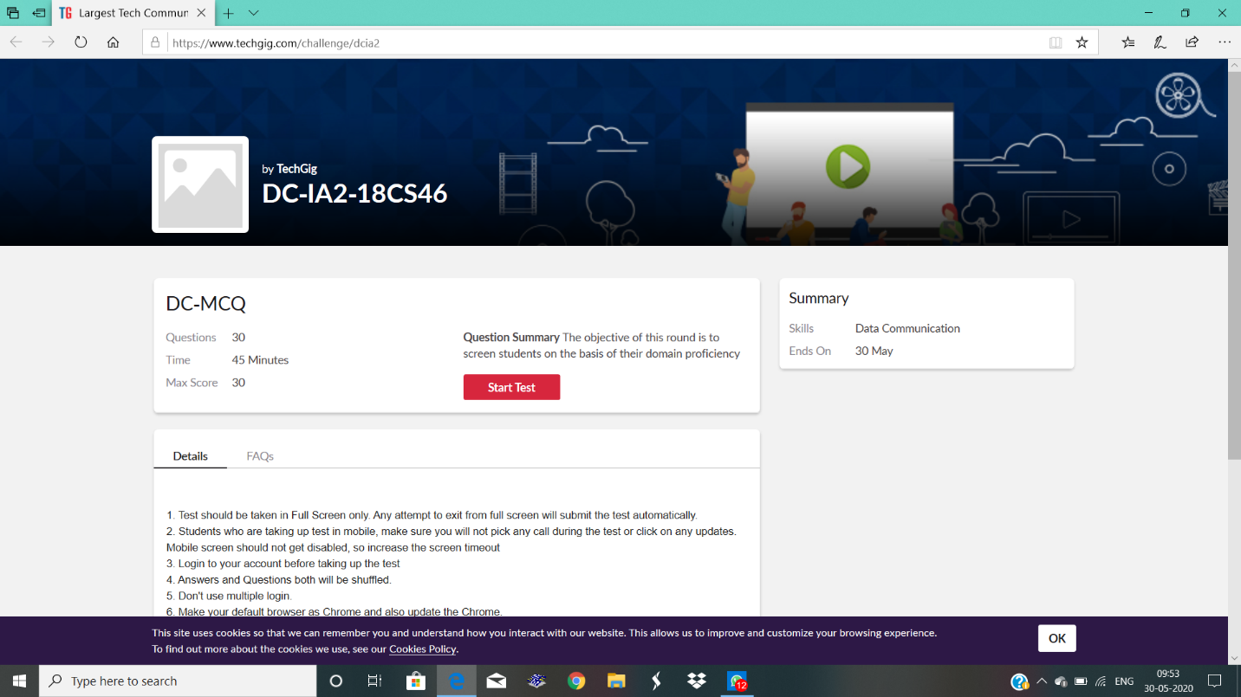

Certification Course Details: I continued course and completed 2 modules. Course completed.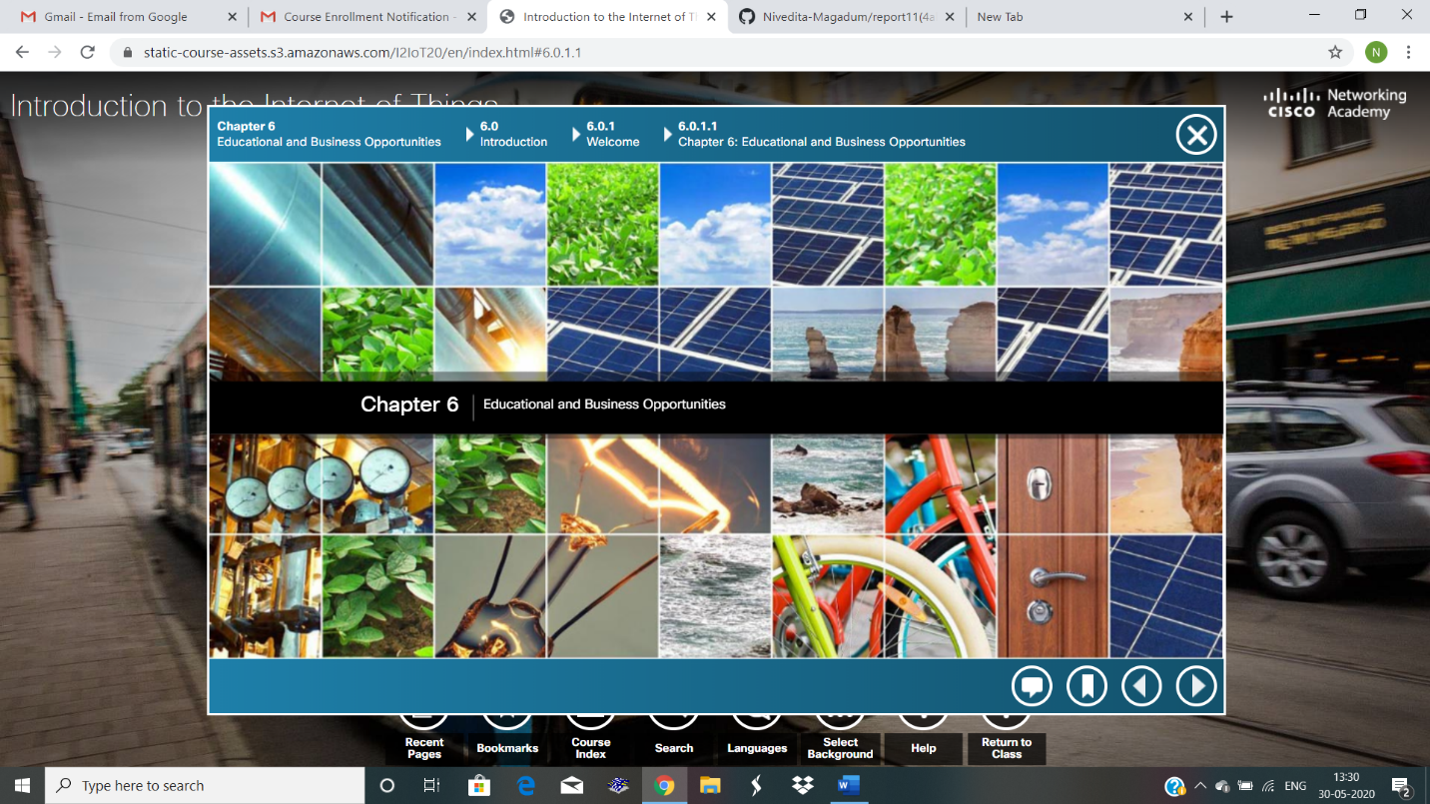

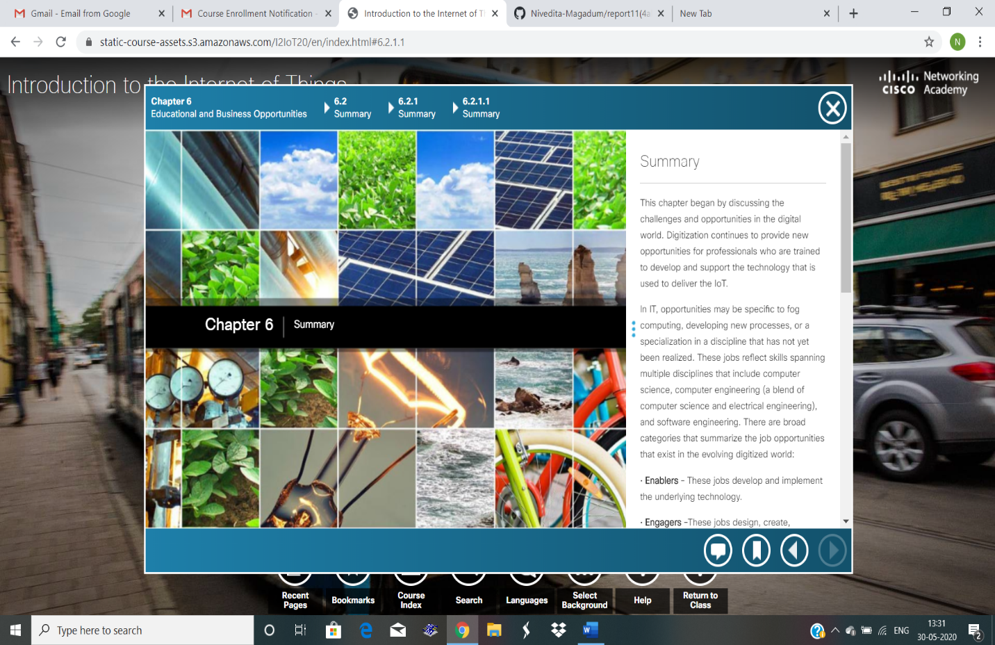

Coding Challenges Details:  Write a C Program to count Uppercase, Lowercase, special character and numeric values for a given String

Executed and uploaded in git hub